**1.Introduction:**

**============**

A wrapper is layer around existing item. So we can use existing item facilities and wrapper facilities through wrapper.

Example:-

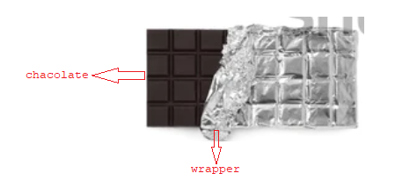

* ServletWrappers are given to develop custom request obj and custom response obj as wrappers on servletcontainer created request, response objs.
* We can use custom request object and custom response object to customize the functionalities of certain methods.

2.Need of custom request object:

=======================

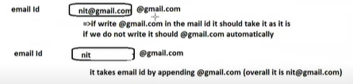

The ready made req.getparameter(-) does not have this capability.. so we need to develop custom logic for req.getParameter(-) method internally using already available logic.

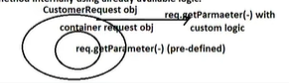

3.Need Of CustomResponse Obj:

=======================

If we want to add additional content to every response then we need to write our choice logics for res.getWriter() method where we create our choice stream object writing out choice destination, So that we can take that written content to modify it or add additional content at end .

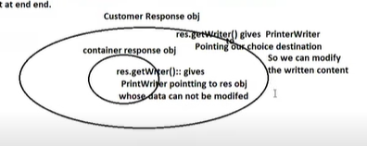

After creating these custom request and custom response objects on servlet container created request,response objects to pass to servlet comp, we need to take support of Filter by calling chain.doFilter(-,-) with custom req, custom res objs.

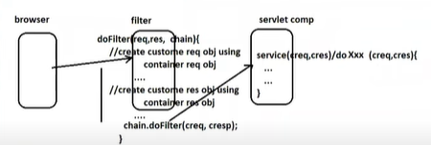

4.Problems and Solutions:

==================

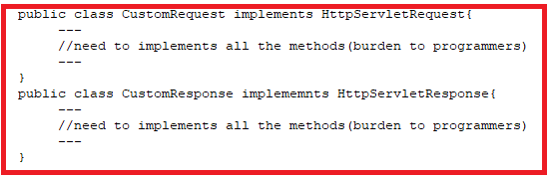

Solution:

Different Readymade Wrapper classes

==========================

ServletRequestWrapper

ServletResponseWrapper

HttpServletRequestWrapper

HttpServletResponseWrapper

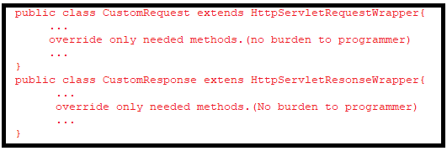

Example: It Demonstrates the custom request and custom response.

=======

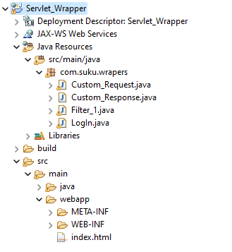

Index.html

========

<!DOCTYPE html>

<html>

<head>

<meta charset="UTF-8">

<title>Insert title here</title>

</head>

<body>

<form action='./LogIn' method="get">

UserName:<input type="text" name="uname"/></br>

Pwd:<input type="password" name="pwd"/></br>

<input type="submit"/>

</form>

</body>

</html>

Custom_Request.java

===============

**package** com.suku.wrapers;

**import** jakarta.servlet.Servlet;

**import** jakarta.servlet.http.HttpServletRequest;

**import** jakarta.servlet.http.HttpServletRequestWrapper;

**public** **class** Custom_Request **extends** HttpServletRequestWrapper {

HttpServletRequest req;

**public** Custom_Request(HttpServletRequest req) {

**super**(req);

**this**.req=req;

}

@Override

**public** String getParameter(String x) {

String s1=req.getParameter("uname");

**if**(!s1.endsWith("@gmail.com"))

{

s1=s1+"@gmail.com";

}

**return** s1;

}

}

Custom_Response.java

=================

**package** com.suku.wrapers;

**import** java.io.CharArrayWriter;

**import** java.io.IOException;

**import** java.io.PrintWriter;

**import** jakarta.servlet.http.HttpServletResponse;

**import** jakarta.servlet.http.HttpServletResponseWrapper;

**public** **class** Custom_Response **extends** HttpServletResponseWrapper {

HttpServletResponse res;

CharArrayWriter writer;

**public** Custom_Response(HttpServletResponse response) {

**super**(response);

**this**.res=response;

writer=**new** CharArrayWriter();

}

**public** PrintWriter getWriter()**throws** IOException{

PrintWriter pw=**new** PrintWriter(writer);

**return** pw;

}

**public** String toString() {

**return** writer.toString();

}

}

Filter1.java

========

**package** com.suku.wrapers;

**import** java.io.IOException;

**import** java.io.PrintWriter;

**import** jakarta.servlet.FilterChain;

**import** jakarta.servlet.ServletConfig;

**import** jakarta.servlet.ServletException;

**import** jakarta.servlet.annotation.WebFilter;

**import** jakarta.servlet.http.HttpFilter;

**import** jakarta.servlet.http.HttpServletRequest;

**import** jakarta.servlet.http.HttpServletResponse;

@WebFilter("/*")

**public** **class** Filter_1 **extends** HttpFilter {

**public** **void** init(ServletConfig config) **throws** ServletException {

// **TODO** Auto-generated method stub

}

**public** **void** doFilter(HttpServletRequest req,HttpServletResponse res,FilterChain fc) **throws** IOException, ServletException

{

PrintWriter pw=res.getWriter();

res.setContentType("text/html");

Custom_Request cr=**new** Custom_Request(req);

Custom_Response cr1=**new** Custom_Response(res);

fc.doFilter(cr, cr1);

String s=cr1.toString();

s=s+"<br><h2>sukumar</h2>";

pw.write(s);

}

}

Login.java

========

**package** com.suku.wrapers;

**import** java.io.IOException;

**import** java.io.PrintWriter;

**import** jakarta.servlet.ServletException;

**import** jakarta.servlet.annotation.WebServlet;

**import** jakarta.servlet.http.HttpServlet;

**import** jakarta.servlet.http.HttpServletRequest;

**import** jakarta.servlet.http.HttpServletResponse;

**public** **class** LogIn **extends** HttpServlet {

**protected** **void** doGet(HttpServletRequest req, HttpServletResponse res) **throws** ServletException, IOException {

PrintWriter pw=res.getWriter();

res.setContentType("text/html");

String s1=req.getParameter("uname");

String s2=req.getParameter("pwd");

**if**(s1.equalsIgnoreCase("suku@gmail.com"))

{

pw.write("<h2 align='center'>Valid Credentials</h2>");

pw.write("<h2>UserName:"+req.getParameter("uname")+"</h2>");

}

**else** {

pw.write("<h2 align='center'>InValid Credentials</h2>");

pw.write("<h2>UserName:"+req.getParameter("uname")+"</h2>");

}

pw.close();

}

}

Web.xml

=======

<?xml version=*"1.0"* encoding=*"UTF-8"*?>

<web-app xmlns:xsi=*"http://www.w3.org/2001/XMLSchema-instance"* xmlns=*"https://jakarta.ee/xml/ns/jakartaee"* xsi:schemaLocation=*"https://jakarta.ee/xml/ns/jakartaee https://jakarta.ee/xml/ns/jakartaee/web-app_6_0.xsd"* id=*"WebApp_ID"* version=*"6.0"*>

<display-name>Servlet_Wrapper</display-name>

<welcome-file-list>

<welcome-file>index.html</welcome-file>

</welcome-file-list>

<servlet>

<servlet-name>LogIn</servlet-name>

<servlet-class>com.suku.wrapers.LogIn</servlet-class>

</servlet>

<servlet-mapping>

<servlet-name>LogIn</servlet-name>

<url-pattern>/LogIn</url-pattern>

</servlet-mapping>

<servlet>

<description></description>

<display-name>Custom_Request</display-name>

<servlet-name>Custom_Request</servlet-name>

<servlet-class>com.suku.wrapers.Custom_Request</servlet-class>

</servlet>

<servlet-mapping>

<servlet-name>Custom_Request</servlet-name>

<url-pattern>/Custom_Request</url-pattern>

</servlet-mapping>

<servlet>

<description></description>

<display-name>Filter_1</display-name>

<servlet-name>Filter_1</servlet-name>

<servlet-class>com.suku.wrapers.Filter_1</servlet-class>

</servlet>

<servlet-mapping>

<servlet-name>Filter_1</servlet-name>

<url-pattern>/Filter_1</url-pattern>

</servlet-mapping>

<servlet>

<description></description>

<display-name>Custom_Response</display-name>

<servlet-name>Custom_Response</servlet-name>

<servlet-class>com.suku.wrapers.Custom_Response</servlet-class>

</servlet>

<servlet-mapping>

<servlet-name>Custom_Response</servlet-name>

<url-pattern>/Custom_Response</url-pattern>

</servlet-mapping>

</web-app>

Output:1

=======

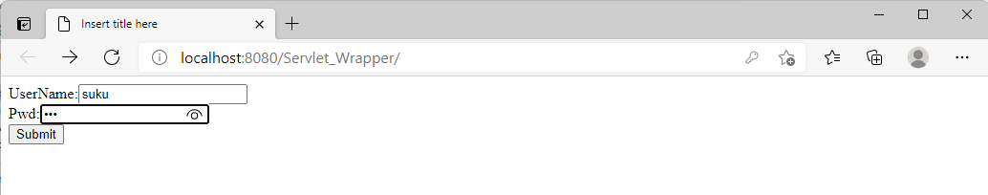

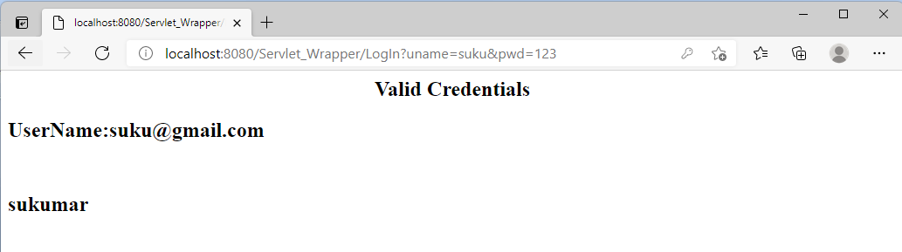

Output:2

========

